***SINDH MADRESSATUL ISLAM UNIVERSITY***

***DEPARMENT: SOFTWARE ENGINEERING***

***SEMESTER/SECTION: 2(B)***

***ID: BSE-22S-084***

***SUBJECT: SOFTWARE ENGINEERING***

***COURSE CODE: SEN-102***

***SUBMIT TO: MS. WAJEEHA NAIM***

***SUBMIT BY: MUHAMMAD MUBASHIR***

**REPORT OF THE SCRUM**

**Introduction**

Carrying out Nimble improvement process is conceivable utilizing Scrum structure. Scrum considers a steady and iterative improvement approach, rather than the cascade worldview of programming advancement. The task is separated into different stages, every one of which creates a completed decent. A usable item is given to a client at the finish of each stage, which is alluded to as a "run" in Scrum dialect. Client input helps with recognizing expected issues or on the other hand, if essential, altering the first improvement system. The Scrum approach can assist you with remaining on the right track in the event that you believe your undertaking should stick rigorously to the essentials of the Dexterous pronouncement.

As per the Scrum system, coming up next are the essential obligations took part in the improvement cycle:

The Scrum ace sorts out the whole advancement process, while the item proprietor pays special attention to the interests of the end client. Making guaranteeing Scrum is applied accurately and holding successive Scrum gatherings are extra undertakings. The Scrum group creates the item. Its essential obligations incorporate testing, examination, and programming.

We should now look at the essential phases of the Scrum-based improvement process.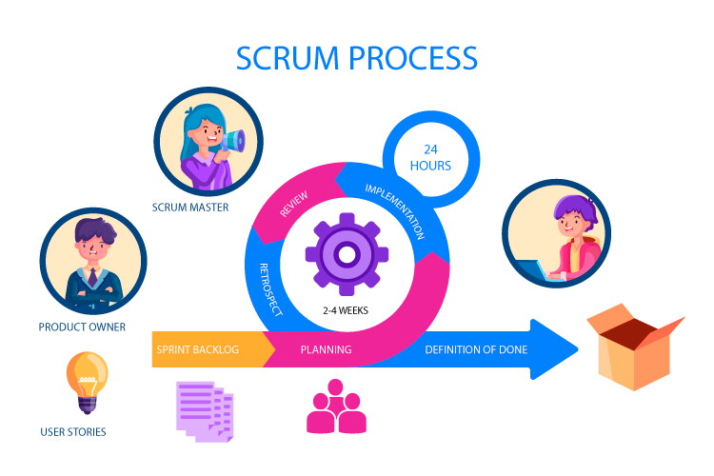

**Phases of Scrum Model**

**Step 1. Product Backlog Creation**

A rundown of highlights that will be executed during the improvement cycle is known as an item build-up. Every thing is alluded to as a "Client story" and is organized in need request. Each client story is given an extraordinary ID. Client stories commonly follow the configuration: I need to [feature body] as a [User Role] so [User Profit]. This rundown exhibits a few potential organizations for these stories. These are genuine details for the item that were tried during the product improvement process:

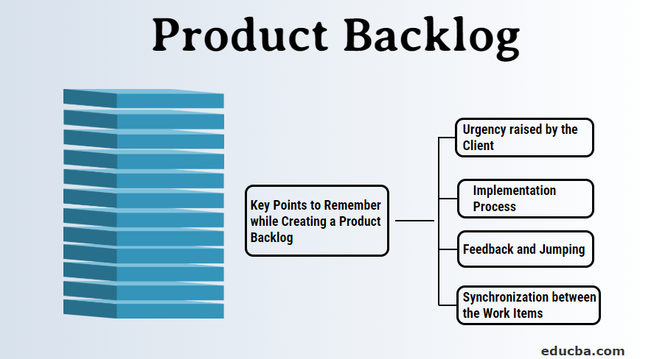

**ID User Story**

a-001 to all the more likely control the venture, I need to have the option to deal with the responsibility of my colleagues by adding, erasing, and altering tasks.

a-002 for me to have the option to gauge the complete venture time, I need to have the option to add new errands and change the length and beginning date of the ones that are as of now there utilizing simplified.

a-003

I need to distribute parttime and full-time tasks to representatives as a chief with the goal that I might better oversee task need.

Notwithstanding these essential fields, the accompanying discretionary ones might be added:

To change their need, all client stories of a specific sort are picked utilizing the track. Can be utilized, for example, to raise the need of client stories connected with the Control board.

A rundown of the parts that will be changed during the undertaking is comprised of parts. The modules of an application, like confirmation or search, for example; The requester is a client who is keen on making a particular component.

A rundown of found surrenders with a legitimate client story is contained in the bug following ID.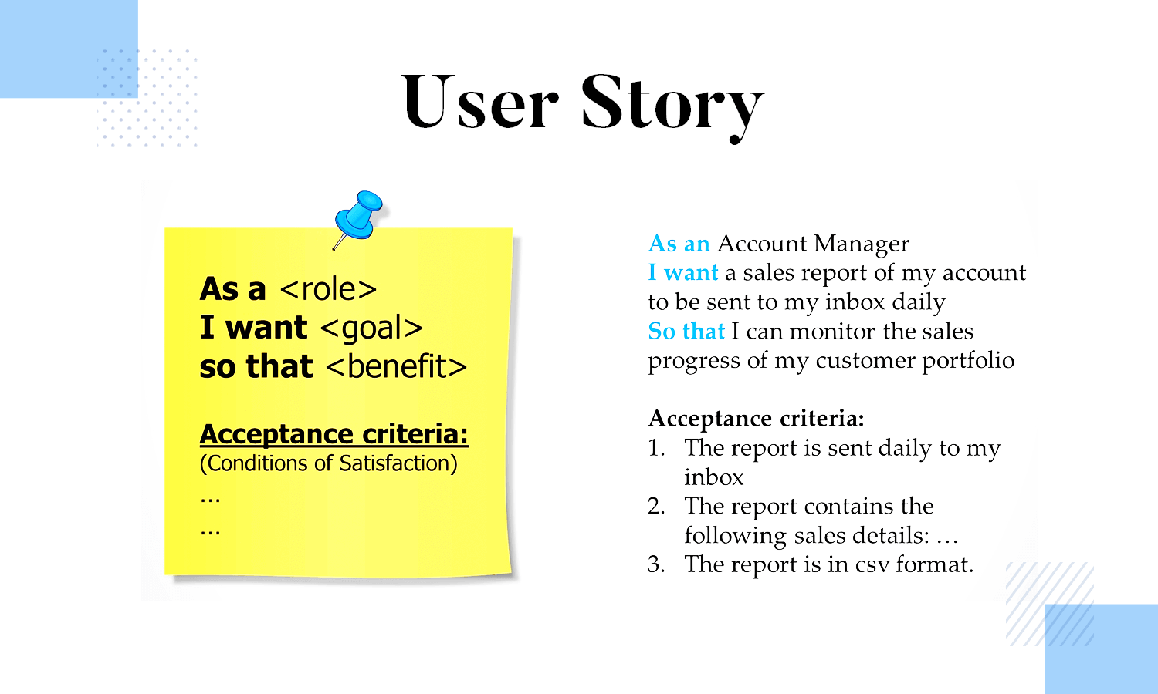

**Step 2. Sprint Planning and Sprint Backlog Creation**

You ought to initially conclude how long your run will endure. You can convey the functional rendition of an item more habitually with short runs. Thus, shopper information will be accumulated all the more habitually, and every single expected imperfection and mistakes will be found in the near future.

A drawn out run span is a choice also. Designers will actually want to work all the more industriously accordingly. The normal of these two choices is utilized to decide the best run length. In a Scrum worldview, a run commonly endures 2 a month. The Run Objective is more urgent at this stage. For each run, an objective is picked. Client stories are integrated into the run as per this. The joint effort of colleagues and partners is another pivotal element. The worth of a decent client not entirely set in stone by the item proprietor, and the Scrum group lays out the sensible work costs.

The Scrum group can then pick the most essential client stories from the item excess after that. From that point onward, colleagues should conclude how they will move toward every task. Furthermore, the group can separate explicit client stories into their littlest parts prior to transforming them into a bunch of exercises. The subsequent stage is to build the Run excess. Comprised of client stories will be done in the ongoing run. The amount of these not entirely settled by the quantity of story focuses that were apportioned to every story during the audit stage. These accounts ought to have the option to be finished by the Scrum group on time.

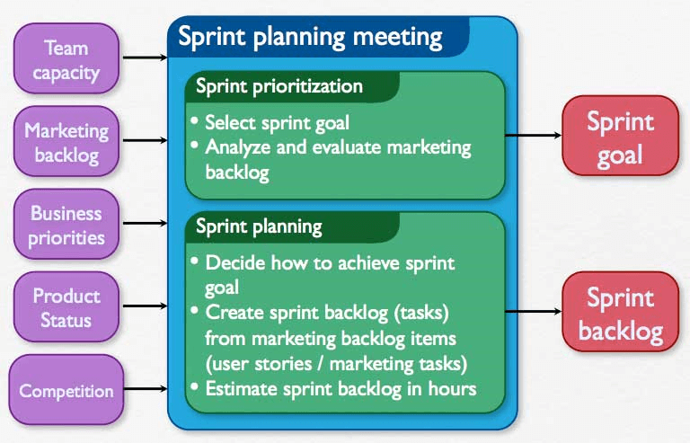

**Step 3. Working on the Sprint. Daily Scrum Meetings**

The advancement interaction begins after the genuine client stories for the ongoing stage are chosen.

An errand board is regularly used to screen the continuous work process.

Normally, there are enormous cards with the names of explicit client stories and an assortment of little tacky notes with depictions of the singular exercises expected to execute every story. Each single board is made in view of the necessities of an undertaking. We should check a concise representation out.

Sorting out the cards arranged by importance is conceivable. The matching sticker is moved from the "To do" field to the "underway" field once work on a task has started. The sticker can be set in the "Testing" field once the work is done, and it moves to the "Done" field once the assignment has been effectively tried. A delineation of how the Scrum task board might show up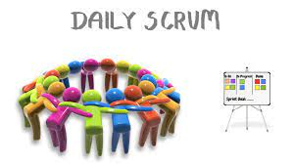

***SCRUM***

The work of specific programming is one more choice for this undertaking.

take Atlassian JIRA, for example.

Everyday Scrum gatherings are a critical part of the Scrum system. The significant goals of these gatherings are to guarantee that everybody in the group is in total agreement and to get exact and finish data about the condition of the undertaking. Each colleague ought to share their advancement on the Run Objective, the errand that will come straightaway, and any difficulties they experienced all through the work during Scrum meetings.

A burndown outline is another regularly utilized instrument that empowers effective checking of ordinary techniques. It shows the number of tasks that are as yet extraordinary. This graph takes into account the control of the advancement interaction and can be changed following each gathering.

Everyday Scrum meetings add to the advancement cycle's expanded versatility. They additionally empower understanding of the fundamental changes.

The Y-hub shows the absolute number of story focuses for the ongoing stage, while the X-hub shows the quantity of working days left. Whenever a task that needs a specific measure of story focuses to complete is done, you can add a highlight the chart to show the headway that has been made.

You may likewise construct similar diagrams with JIRA:

**Burndown chart**

This chart supports grasping the ongoing pace of work. How much client stories for the accompanying run might change considering these discoveries.

It's memorable's vital that the entire life-cycle testing process is significant on the grounds that the ideal result of each and every run in the Scrum model is a usable item. There are different methodologies for lessening the testing time frame's consumptions. You may, for example, cut back on the general volume of client stories. Accordingly, the probability of bugs will be diminished. On the other hand, QA specialists can be consolidated inside the Scrum group.

See additionally Why QA Is Significant in the Advancement of Top notch Programming Items.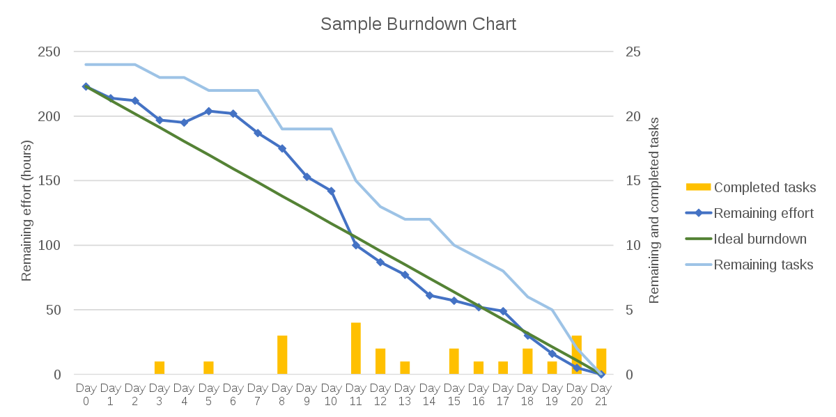

**Step 4. Product Increment and Sprint Review**

Each run in Scrum creates a steady item that might be sent and that can be displayed to the client. The product improvement group delivers a new, more significant form of an item with every emphasis. The general outcomes can be shown and analyzed during the Run Survey, which is the last period of each run. The partners can choose what extra task enhancements to make and can arrangement the accompanying run in view of the entirety of this data.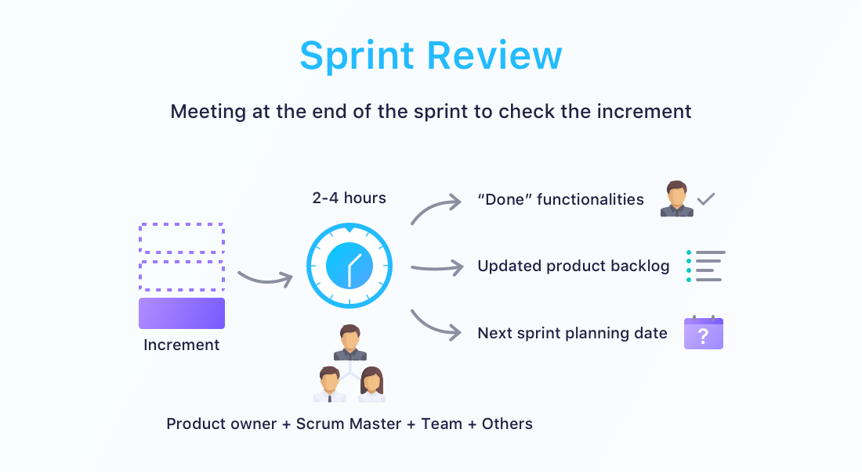

**Step 5. Retrospective and Next Sprint Planning**

The principal objective of a review is to look at the discoveries and choose how to make coming up next step's improvement interaction better. A vital viewpoint is that as of now, the work and communication processes are the ones that are examined to improve crafted by the Scrum group all in all. The group ought to come to an agreement over what functioned admirably during the functioning system and what might be improved during resulting cycles. The group can zero in on the following run arranging once the techniques for development have been recognized.



**Conclusion**

Nimbleness and nonstop improvement are Scrum's two key distinctive qualities. It is principally given by continuous correspondence and tight participation among all gatherings required at each stage. The Scrum approach recommends a continuous gradual and iterative improvement process. The goal is to ensure the capacity to consistently raise the worth of the item and save adaptability in choosing needs for resulting cycles.

The client can survey the functioning item's usefulness toward the finish of the run and choose with sureness how the venture ought to progress in the accompanying runs.

Nothing precludes engineers from using a Software Requirements Specification, even if the Agile manifesto recommends favoring usable software above thorough documentation. SRS excels at describing systems.